COMP6251 Web and Cloud Applications
Development Coursework

Team 10

The Cloud Surgery Application

Martin Ingram  mi2n23@soton.ac.uk  Student ID: 35475277 | Raghav Mittal rm6n23@soton.ac.uk  Student ID: 35117311 | Sahil Hasan Laskar shl1e23@southampton.ac.uk  Student ID: 35477016

1. Prototype Functionality

1.1 Requirements Analysis
Based on the requirements supplied, we determined that there were two classes of user
- Patients, who should be able to register and request appointments, but should be restricted to view-only functionality for all other types of data.
- Staff, who should be able to approve registration requests, book appointments based on requests from patients and have full create / read / update / delete capabilities for the other types of patient information.
Given these restrictions, we decided that functionality should be partitioned by these user types, with separate logins and menus.
The overall structure of the application (pages and menus) is illustrated in Appendix B, Fig. 1.
A detailed data model is provided in Appendix B, Fig. 2.

1.2 Feature List
The features we have included in the prototype are:

1.2.1 Patient Pages
Page | Description
Patient Registration | A four-step wizard that allows new patients to request registration with the surgery, including GDPR preferences.
Patient Login | Authenticates staff (employee) users.
Patient Services Menu | Lists the features available to patients.
Update Your Details | Allow a patient to update their details.
Request An Appointment | Allow a patient to request an appointment, including a list of the days that they are available.
View Your Appointments | Views a list of appointments for a patient
View our Medical History | Views a list of medical history entries for a patient
View Your Prescriptions | Views a list of prescriptions for a patient
View Your Tests | Views a list of tests booked for a patient.

1.3.2 Staff Pages
Page | Description
Staff Login | Authenticates staff (employee) users.
Staff Services Menu | Lists the features available to staff.
Appointment Requests | Views a list of unprocessed appointment requests
Book Appointment | Creates an appointment from an appointment request
Registration Requests | Views a list of unprocessed patient registration requests
Registration Approval | Sets up a new patient based on a registration request, including assigning a registered doctor.
View Patients | Views a list of patients
Patient Details | Views the details of a selected patient
View Medical History | Views a list of medical history entries for a patient
Medical History Details | Views and updates the details of a selected medical history entry. A member of staff can also create a new medical history note.
View Prescriptions | Views a list of prescriptions for a patient
Medical History Details | Views and updates the details of a selected prescription. A member of staff can also create a new prescription.
View Tests | Views a list of tests booked for a patient.
Medical History Details | Views and updates the details of a selected medical test entry. A member of staff can also set up a new medical test.
View Employees * | Views a list of all employees
Employee Details * | Views the details of a selected employee. Also allows a member of staff to set up a new employee.
Reset Employee Password * | Password reset for a selected employee.

* These additional features were not mentioned in the specification but deemed necessary for the application to work.

2. Tools and Techniques

2.1 Additional Dependencies
We chose to use several popular open source dependencies to complement the standard React Hooks libraries and JSON Server. These are listed below and can also be found in our main package.json file.
Dependency | Version | Used For
Material UI | 5.15.14 | Standard form components
Material UI Date Picker | 7.1.0 | The date picker in Patient Registration
Axios | 1.6.8 | REST API calls
DayJS | 1.11.10 | Date and time persistence and formatting
MD5 | 2.3.0 | MD5 password hashing
Validator | 13.11.0 | Simple form validation e.g. post code, email address

2.2 Techniques
Techniques and software engineering practices used included:
Technique | Used For
Material Themes | Consistent styling of form components across pages. See listing A8 in Appendix A.
Localisation | Consistent formatting of dates for a locale. See listing A7 in Appendix A.
Object Modelling | Database design and REST API contracts. Our final object model can be found in Appendix B Fig. 2.
Wireframing | Form design prior to development. An example can be found in Appendix B Fig. 3.
Don’t Repeat Yourself (DRY) | We experimented with reusable components. An example can be found in Appendix B listings 9 and 10.
Version Control | We used GitLab to distribute and maintain our codebase across the development team. We commited and pushed to the central repository regularly (minimum daily) to ensure that merge conflicts etc. were minimised. An example screenshot can be found in Appendix B Fig. 9.
Kanban Board | We used a simple Kanban board hosted on Azure DevOps to keep track of our progress. See Appendix B Fig. 10.
Online Whiteboarding | We collaborated on the design using an online whiteboard (Miro) so that we could work effectively but remotely. The whiteboard also became our single source of truth for design decisions etc.
Agile Techniques | We held regular standups (every other day) to ensure that we all understood our current workload.

3. Design and Implementation

3.1 React Hooks
Standard React Hooks techniques (State, Context, Routes, Providers, Reducers, Navigate, useResource, useEffect etc.) were used to build each page.
Example code can be found in Appendix A, listings A1 to A7.

3.2 Key Design and Development Principles
Principle | Rationale
Satisfy use cases with the minimum number of clicks | Users should not have to navigate a complicated user interface to get their work done.
Prevent users from taking action rather than throwing error messages when they do, e.g. disabling buttons until all mandatory fields are completed. | Excessive error messaging is a frustrating user experience. See Appendix B, Fig. 8 for an example of a disabled user action.
Validate data (e.g. format checks) only when it is really helpful. | Again, excessive validation can be irritating, e.g. expecting a phone number to be typed in a particular format. See Appendix B, Fig. 8 for an example of a helpful validation check (password consistency).
A consistent user experience, e.g. Lists of data which when clicked reveal further details for a specific entry. | A consistent, clear user experience is much easier to learn and use. Each feature should work in the same way as the others. See Appendix B, Fig. 5 and 6 for examples of List and Detail views.
Use industry standard / open source frameworks rather than reinventing the wheel. | “Not invented here” syndrome can plague a project once it reaches a certain size. Popular frameworks and libraries often implement standard features in a much better way than bespoke equivalents.
State objects for singular and list of objects | Efficient data management, improved performance, and consistency throughout the application.
Don’t fetch anything from the REST service that we already have in state. | Minimises network traffic, improves performance.
Store all passwords as hashes | Secure one way hashing protects user credentials. Additionally, measures were taken to optimise performance, such as minimising unnecessary fetch requests from the REST API.
Unique automatically generated IDs rather than using data for primary keys. | Allows the database to be refactored much more easily.
Use a working day calendar (Mon - Sat for the next two weeks) rather than open ended date pickers. | This simplifies the user experience by reducing the number of clicks required to select dates. It also simplifies the implementation of the date related functionality, reducing the amount of sanity checking required. See Appendix B, Fig. 7 for an example of this in use.
Differentiate between primary and secondary actions using button styles. | This provides helpful guidance regarding what the expected action is likely to be. See Appendix B, Fig. 4 for an example.

4. Testing Strategy

4.1 Manual Testing
Manual testing was carried out on an ongoing basis using a range of desktop browsers including Chrome, Edge, Safari, Brave, and Firefox and across a number of platforms and mobile devices.
- macOS (Sonoma), Windows 10, Linux (ElementaryOS 7)
- iPhone (iOS 14) and iPad (iPadOS 14)
The testing focused on verifying business logic and checking for UI responsiveness.

4.2 Patient User Journey
- Check if a user can register as a patient and then log in with credentials, with the password stored in an encrypted form (MD5) in the database.
- Can a new patient use all of the listed services such as request an appointment, update their details, view medical history, view prescriptions and view tests.
- Is the relevant data being updated in the test database with the correct values when the forms are submitted?
- Test that the correct patient details are reflected on the webpage while fetching them from test database.
- Check if patients can access all the information regarding their tests, prescriptions and medical history in real time.
- Test whether patients are able to get the appointment dates they booked for.
- Checked the logout functionality.

4.3 Staff User Journey
- Check that new employees can be added to the system.
- Is the password is stored in an encrypted form?
- Can a new member of staff log in with the details provided?
- Is an error message displayed if they enter the wrong credentials?
- Can staff book appointments based on incoming requests from patients and select an available doctor?
- Can administrators approve or reject registration requests?
- Can staff find patient details based on name, postcode and/or email?
- Can staff create, view, update and delete prescriptions, medical history and tests?
- Can administrators see a list of employees with their roles and can they update, delete and reset the passwords for any of the employees?
- Test if staff can log out.

5. Statistics

5.1 Lines of Code
Category | Line Count
Application configuration (root directory of /src) | 197
Context component | 5
Reusable components | 659
Reusable utility functions | 76
Patient Pages | 1218
Staff Pages | 2469
Reducers | 393
TOTAL | 4941

5.2 Code References
Code was not lifted wholesale from any of these sources, but the following were used as references for best practice, implementation patterns etc.
Source | Description
Learn React Hooks, Daniel Bugl, Packt, Oct 2019 | Reference book for this module, supplementing the lecture notes.
https://mui.com/material-ui/all-components/ | Material UI Components Reference Guide
https://day.js.org/docs/en/installation/installation | DayJS Reference Guide
https://www.npmjs.com/package/validator | Validator.JS Reference Guide
https://www.npmjs.com/package/md5 | MD5 Reference Guide

5.3 Version Control
The University of Southampton GitLab service was used for version control.
We created a private group:
https://git.soton.ac.uk/comp6251-group-10
and then a source code project for our work within that group:
https://git.soton.ac.uk/comp6251-group-10/web-coursework
We also created a sandbox for experimentation:
https://git.soton.ac.uk/comp6251-group-10/web-sandbox
A screenshot of our GitLab repository is provided in Appendix B, Fig. 9.

6. Prototype Evaluation
The application as it stands is fully functional, but further work would add considerable value.
Feature | Benefits
External hosting | Public and private access to all users.
HTTPS | Ensures confidentiality and data integrity.
Login checks on each page | We implemented login checks on some pages for proof of concept only. This needs to be rolled out across the application.
Remote database (e.g. Firebase) | Resilient data management and scalability.
Lock down the REST API | As implemented the REST API is public facing and open to abuse.
Automated testing using Selenium, Cucumber, Jest or Enzyme | Manual testing is time consuming and prone to error. Automated tests could be scheduled to run with every build, which in turn could be triggered on each push to the central code repository.
Search and filter | The List pages display all data, which as the database grows in size will become cumbersome.
Appointment conflict checks | The current implementation does not check automatically for double booking etc.
Deployment pipeline | A deployment pipeline running from a Continuous Integration tool such as Jenkins would significantly improve both deployment times and frequency.
Package refactoring -or- separate SPAs for each functional area. | The package structure is currently based around component type (reducer, page etc.) This is likely to get confusing as the application grows, so we would consider restructuring by functional area at this point.
Balancing the “minimise fetch” design with concurrent usage. | At present we populate detail screens from the relevant object in the list screen. In a live environment with many users this may result in out-of-date data being used.
Reusable components rather than copy-paste reuse. | At present many of our pages use very similar layouts. Development and maintenance would be much simpler if these layouts were consolidated into reusable components.
Visual enhancements | At present the application consists of functional forms only. For live deployment, we would need to incorporate branding for the surgery.

Appendix A – Code Samples

A1. The State model defined in App.js
const [ state, dispatch ] = useReducer(appReducer, {
appointment: initialAppointment,
appointments: [],
appointmentRequest: initialAppointmentRequest,
appointmentRequests: [],
employee: initialEmployee,
employees: [],
prescriptions: [],
prescription: initialPrescription,
tests: [],
test: initialTest,
error: '',
register: initialRegister,
registrations: [],
user: initialUser,
patients: [],
medhistory:initialMedHistory,
medhistorys:[]
})

A2. The State Context definition in contexts/context.js
export const StateContext = React.createContext({
state: {},
dispatch: () => {}
})

A3. An example reducer from reducers/userReducer.js
export const initialUser = {
id: -1,
name: "",
role: "none"
}
export function userReducer(state, action) {
switch (action.type) {
case "LOGIN":
return {
id: action.id,
name: action.name,
role: action.role,
email: action.email,
postCode: action.postCode,
doctorId: action.doctorId
}
case "LOGOUT":
return initialUser
default:
return state
}
}

A4. Example routes from components/PageContent.js
export function PageContent() {
return (
<Container>
<Router>
<Routes>
<Route path="/" element={<HomePage />} />
<Route path="/patient/appointmentRequest" element={<AppointmentRequestPage />} />
<Route path="/patient/appointments" element={<ViewAppointmentsPage />} />
<Route path="/patient/details" element={<PersonalDetailsPage />} />

// Truncated for brevity

<Route path="/staff/medicalhistorydetail" element={<MedicalHistoryDetails />} />
</Routes>
</Router>
</Container>

A5. Dispatch and navigate from pages/staff/ViewEmployeesPage.js
function handleResetPassword(event) {
dispatch({ type: "RESET_EMPLOYEE_PASSWORD", employee: employee })
navigate("/staff/employeepassword")
}

A6. StateContext Provider From App.js
return (
<StateContext.Provider value={{ state, dispatch }}>
<Banner />
<PageContent />
<Footer />
</StateContext.Provider>
)

A7. Request, theme and localisation providers from index.js
const axiosInstance = axios.create({
baseURL: "http://localhost:3000/api/"
})
root.render(
<React.StrictMode>
<RequestProvider value={axiosInstance}>
<ThemeProvider theme={ theme }>
<LocalizationProvider dateAdapter={AdapterDayjs} adapterLocale="en-gb">
<App />
</LocalizationProvider>
</ThemeProvider>
</RequestProvider>
</React.StrictMode>
);

A8. Material UI theme from theme.js
import { createTheme } from "@mui/material";
export const theme = createTheme({
palette: {
primary: {
main: '#2196F3',
},
secondary: {
main: '#f50057',
},
},
components: {
MuiButton: {
defaultProps: {
variant: "contained"
}
},
// Truncated for brevity
MuiTableRow: {
defaultProps: {
sx: {
verticalAlign: "middle"
}
}
}
}
}
)

A9. An example reusable component from components/StaffOnly.js
export function isLoggedIn(state) {
const { user } = state
return user.role !== "none" && user.role !== "patient"
}
export default function StaffOnly() {
const { state } = useContext(StateContext)
const navigate = useNavigate()
function handleCancel(event) {
navigate("/")
}
function handleLogin(event) {
navigate("/staff/login")
}
return (
<Stack direction="column">
{ !isLoggedIn(state) &&
<Fragment>
<Information text="You must be logged in to access this feature."/>
<Stack direction="row">
<Button onClick={handleLogin}>Login</Button>
<Button variant="outlined" onClick={handleCancel}>Cancel</Button>
</Stack>
</Fragment>
}
</Stack>
)
}

A10. The reusable component in pages/staff/TodaysAppointments.js
return (
<Stack direction="column">
<PageTitle title="View Appointments" />
<StaffOnly />
{ isLoggedIn(state) &&
<Fragment>
<AppointmentList />
<Stack direction="row">
<Button variant="outlined" onClick={handleBack}>Back</Button>
</Stack>
</Fragment>
}
</Stack>
)

A11. An example List View page, pages/staff/TodaysAppointmentsPage
export default function TodaysAppointmentsPage () {
const { state, dispatch } = useContext(StateContext)
const { user } = state
const navigate = useNavigate()
const [ appointments, getAppointments ] = useResource(() => ({
url: "/appointment?staffId=" + user.id + "&_sort=date,time",
method: "get"
}))
useEffect(getAppointments, [])
useEffect(() => {
if (appointments && appointments.error) {
dispatch({ type: "REST_ERROR" })
}
if (appointments && appointments.data) {
dispatch({ type: "FETCH_APPOINTMENTS", appointments: appointments.data })
}
}, [appointments])
function handleBack(event) {
navigate("/staff/menu")
}
return (
<Stack direction="column">
<PageTitle title="View Appointments" />
<StaffOnly />
{ isLoggedIn(state) &&
<Fragment>
<AppointmentList />
<Stack direction="row">
<Button variant="outlined" onClick={handleBack}>Back</Button>
</Stack>
</Fragment>
}
</Stack>
)
}
function AppointmentList() {
const { state } = useContext(StateContext)
const { appointments } = state
return (
<TableContainer>
<Table>
<TableHead>
<TableRow>
<TableCell>Date</TableCell>
<TableCell>Time</TableCell>
<TableCell>Patient</TableCell>
<TableCell></TableCell>
</TableRow>
</TableHead>
<TableBody>
{ appointments.map((appointment, index) => (
<AppointmentSummary key={'appointment-' + index} index={index} />
))}
</TableBody>
</Table>
</TableContainer>
)
}
function AppointmentSummary({ index }) {
const { state, dispatch } = useContext(StateContext)
const navigate = useNavigate()
const { appointments } = state
const appointment = appointments[index]
function handleView(event) {
dispatch({ type: "VIEW_APPOINTMENT", appointment: appointment })
navigate("/staff/appointment")
}
return (
<AlternatingTableRow>
<TableCell>{ displayDate(appointment.date) }</TableCell>
<TableCell>{ appointment.time }</TableCell>
<TableCell>{ appointment.patientName }</TableCell>
<TableCell>
<Stack direction="row" paddingTop={0} paddingBottom={0}>
<Button variant="contained" onClick={ handleView }>View</Button>
</Stack>
</TableCell>
</AlternatingTableRow>
)
}

A12. a typical Detail page supporting full create / read / update / delete, pages/staff/EmployeeDetailsPage.js
export default function EmployeeDetailsPage() {
const navigate = useNavigate()
const { state, dispatch } = useContext(StateContext)
const { employee } = state
const [ title, setTitle ] = useState(employee.title)
const [ firstName, setFirstName ] = useState(employee.firstName)
const [ surname, setSurname ] = useState(employee.surname)
const [ email, setEmail ] = useState(employee.email)
const [ password, setPassword ] = useState(employee.password)
const [ confirmPassword, setConfirmPassword ] = useState(employee.password)
const [ role, setRole ] = useState(employee.role)
const emailValid = email === "" || validator.isEmail(email)
const emailError = emailValid ? "" : "Email address is not the correct format"
const passwordsMatch = (password === confirmPassword)
const passwordError = passwordsMatch ? "" : "Passwords do not match"
const isNew = employee.id === undefined
const deletable = !isNew
const mandatory = email !== "" && emailValid && password !== "" && passwordsMatch
&& title !== "" && firstName !== "" && surname !== "" && role !== ""
const updatedEmployee = {
...employee,
title: title,
firstName: firstName,
surname: surname,
email: email,
role: role
}
const [ , createEmployee ] = useResource(() => ({
url: "employee",
method: "post",
data: { ...updatedEmployee, password: encrypt(password) }
}))
const [ , deleteEmployee ] = useResource(() => ({
url: "employee/" + employee.id,
method: "delete"
}))
const [ , updateEmployee ] = useResource(() => ({
url: "employee/" + employee.id,
method: "put",
data: updatedEmployee
}))
function handleTitle(event) {
setTitle(event.target.value)
}
function handleFirstName(event) {
setFirstName(event.target.value)
}
function handleSurname(event) {
setSurname(event.target.value)
}
function handleEmail(event) {
setEmail(event.target.value)
}
function handlePassword(event) {
setPassword(event.target.value)
}
function handleConfirmPassword(event) {
setConfirmPassword(event.target.value)
}
function handleRole(event) {
setRole(event.target.value)
}
function handleSave(event) {
if (isNew) {
createEmployee()
} else {
updateEmployee()
}
navigate("/staff/employees")
}
function handleDelete(event) {
deleteEmployee()
navigate("/staff/employees")
}
function handleCancel(event) {
navigate("/staff/employees")
}
return (
<Stack direction="column">
<PageTitle title="Employee Details" />
<FormLabel>Title</FormLabel>
<Select id="title" value={title} onChange={handleTitle}>
{ titles.map((option) => (
<MenuItem key={option.value} value={option.value}>{option.label}</MenuItem>
))}
</Select>
<FormLabel>First Name </FormLabel>
<TextField id="firstName" value={firstName} onChange={handleFirstName} />
<FormLabel>Family / Surname</FormLabel>
<TextField id="surname" value={surname} onChange={handleSurname} />
<FormLabel>Email Address </FormLabel>
<TextField id="email" value={email} onChange={handleEmail}
error={!emailValid} helperText={emailError} />
{ isNew && (
<Fragment>
<FormLabel>New Password</FormLabel>
<TextField id="password" value={password} type="password" onChange={handlePassword} />
<FormLabel>Confirm New Password</FormLabel>
<TextField id="confirmPassword" value={confirmPassword} type="password" onChange={handleConfirmPassword}
error={!passwordsMatch} helperText={passwordError} />
</Fragment>
)
}
<FormLabel>Role</FormLabel>
<Select id="role" value={role} onChange={handleRole}>
{ roles.map((option) => (
<MenuItem key={option.value} value={option.value}>{option.label}</MenuItem>
))}
</Select>
<Stack direction="row">
<Button onClick={ handleSave } disabled={ !mandatory }>Save</Button>
<Button onClick={ handleDelete } disabled={ !deletable }>Delete</Button>
<Button variation="outlined" onClick={handleCancel}>Cancel</Button>
</Stack>
</Stack>
)
}

Appendix B – Supporting Diagrams, Wireframes and Screenshots

B.1 Application Model

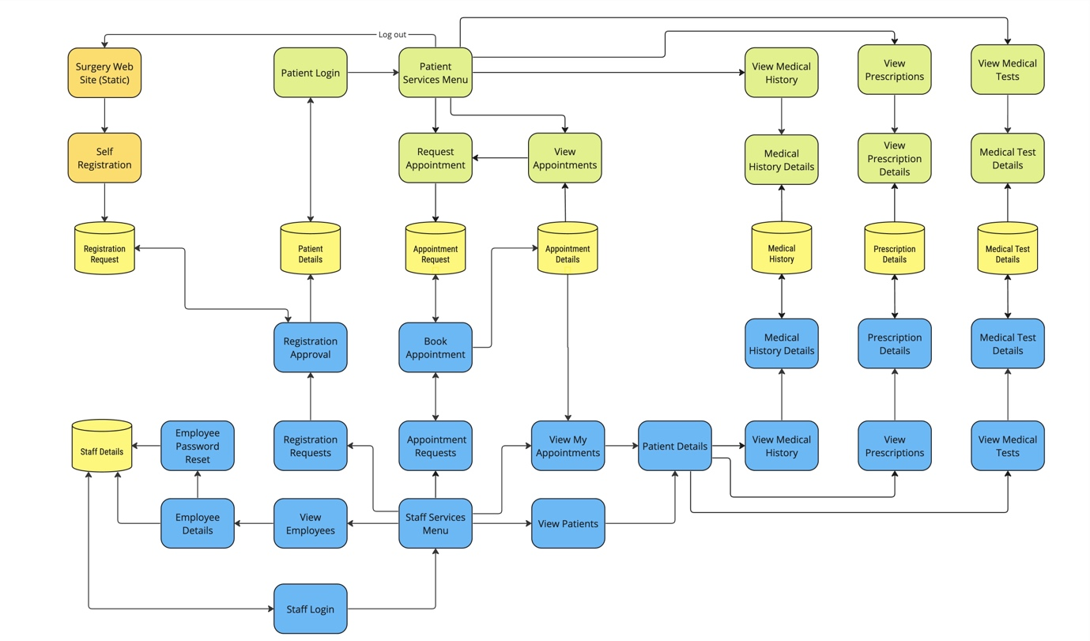
Fig. 1 – Application Screen Flow for Patients (green) and Staff (blue)
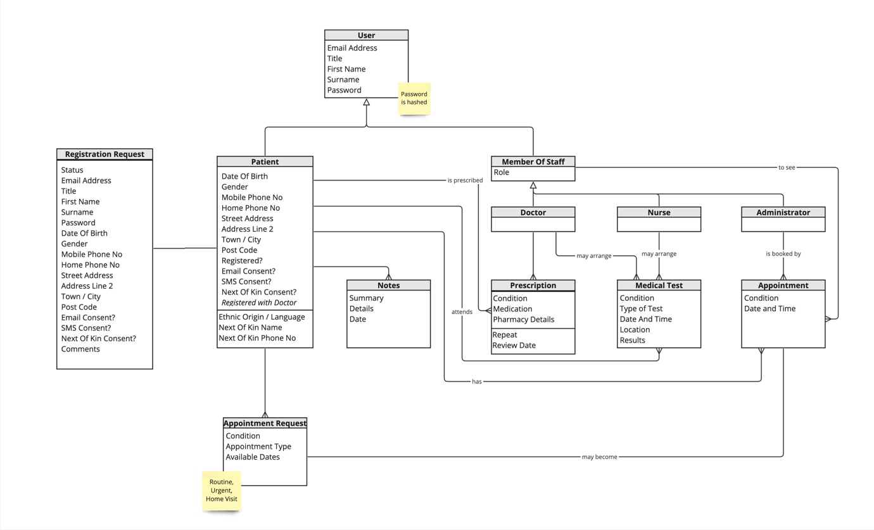
Fig. 2 Application Object Model

B2. Wireframes
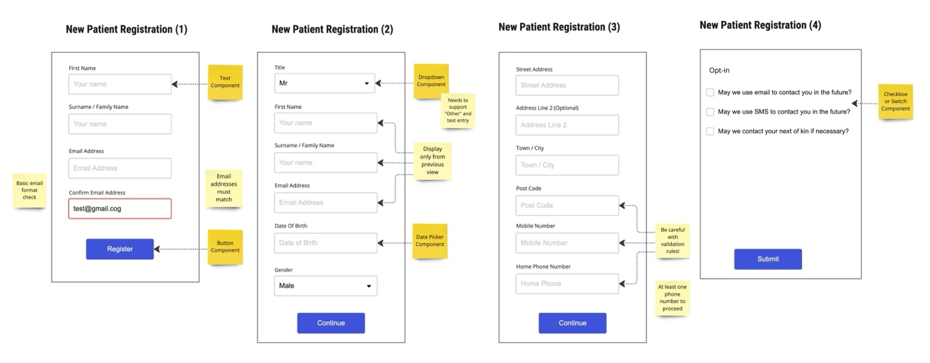
Fig. 3 Example Wireframes for Patient Registration from our Miro board

B3. Example Screenshots

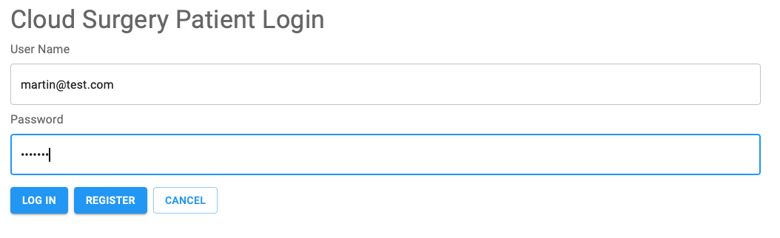
Fig. 4 Patient Login illustrating password masking, primary and secondary action buttons.

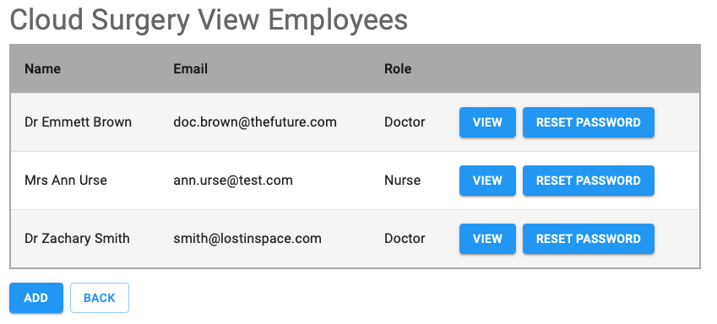
Fig 5. A typical list view with action buttons per row, plus “Add” and “Back” buttons.

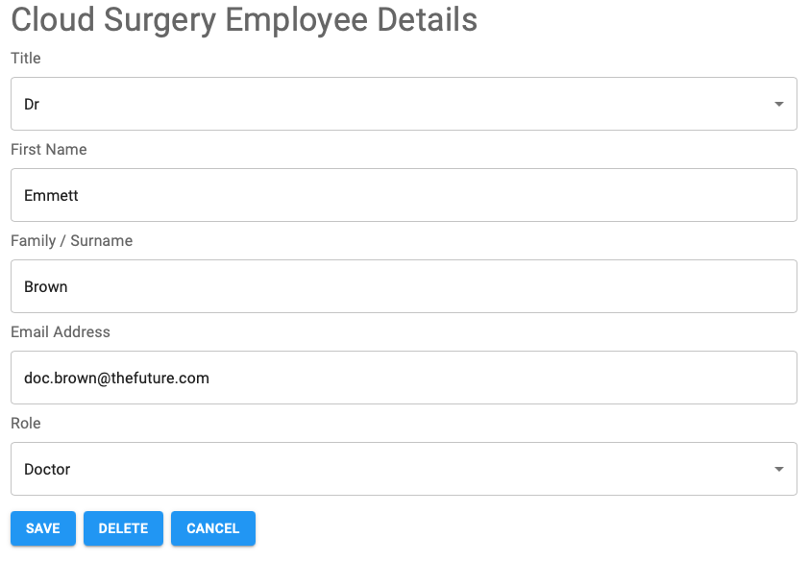
Fig. 6 A typical detail view providing full create, read, update and delete functionality for a type of data. This also illustrates the use of dropdown lists for some data entry fields where specific values must be provided.
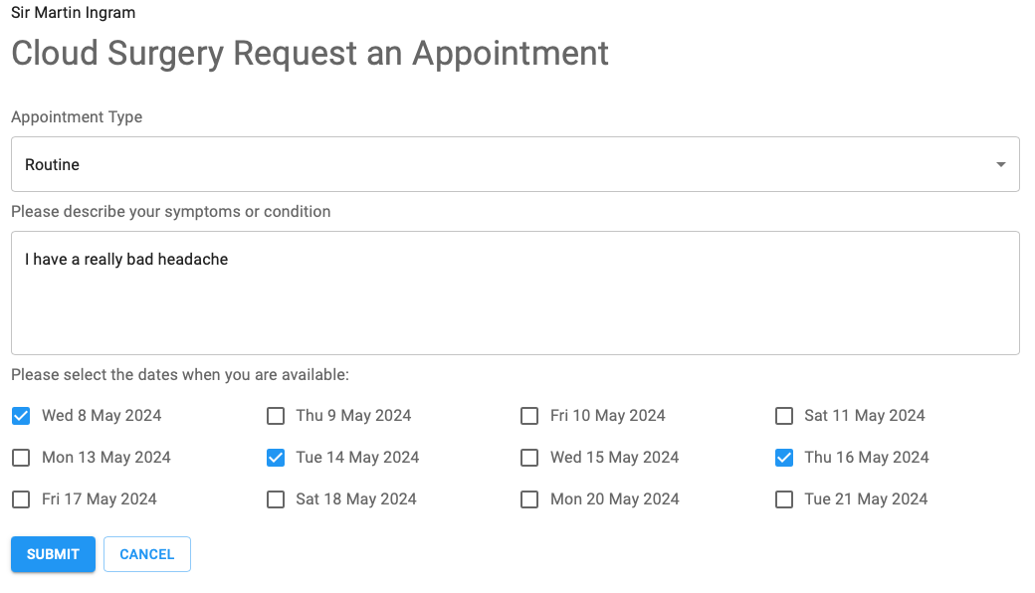
Fig. 7 Request an Appointment screen, showing working day selection using checkboxes.

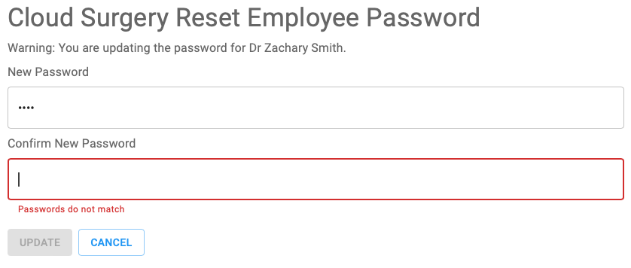
Fig. 8 The Reset Password screen, illustrating simple data validation and disabling of an action button.

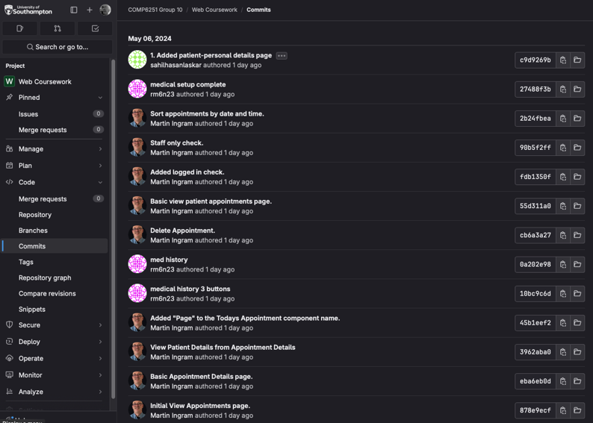
Fig. 9 GitLab

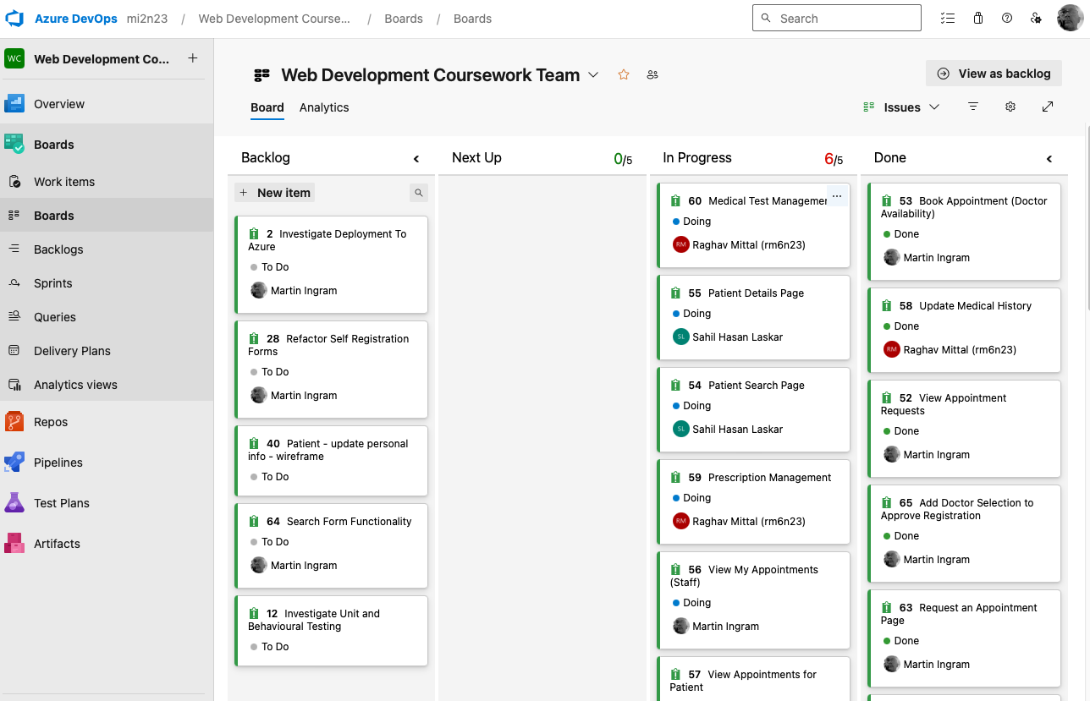
Fig 10. Our Kanban board on Azure DevOps

